Individual Coding Exercise

Introduction
This report presents the design, implementation and testing of a thread-safe banking system. The system allows multiple users to perform transactions concurrently whilst paying particular attention to avoiding concurrency issues. Users are able to deposit, withdraw and check account balances.
The project was developed to demonstrate the principles of object-oriented programming, while applying SOLID principles to improve future maintainability.
As the project progressed, additional functionality was added to validate that multiple transactions would not affect data integrity. This included a TransactionManager class to prevent deadlock during account transfers and overdraft protection.

Object-Oriented Design
The banking system was designed to divide functionality between classes, with the brief specifying the BankAccount class should exist with methods for deposit, withdraw and get_balance, as shown in figure A:
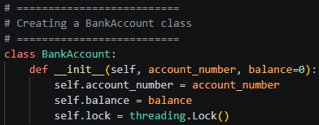
This provided an opportunity to apply Abstraction. As the design progressed, it became clear that allowing other components to access these methods would aid simplicity, allowing interaction with the BankAccount class without needing to explicitly access the underlying account. This approach reduced coupling between classes and any potential need to duplicate logic.
This was later demonstrated in the creation of a TransactionSimulator and DeadlockTestSimulator.

Encapsulation was also applied through the design of the BankAccount class. Account data is contained within the object, and accessed through methods. This design also demonstrates the Single Responsibility Principle as the state and thread synchronisation are contained within the BankAccount class. Consequently, the simulators created later only contained their own responsibilities, improving separation of concerns and maintainability.

Design Decisions and Application of Principles
As the project progressed beyond the initial requirements a number of design decisions were made to improve maintainability, reduce duplication of logic and support the introduction of concurrent processing.
With consideration given to separation of concerns, code reuse and maintainability, responsibilities were divided between classes, each created for specific functions.
The system was designed to separate account management, transaction processing and testing into different classes. This reduced coupling between components and ensured that changes to one area of the system were less likely to affect another.
BankAccount (please refer to Figure A)
BankAccount was responsible for maintaining account state and exposing the core account methods.
TransactionSimulator:
Figure B
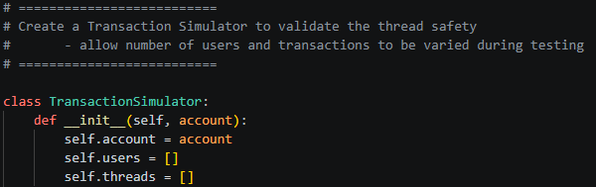
TransactionSimulator was introduced to validate thread safety when multiple transactions were executed concurrently.
DeadlockTestSimulator:
Figure C
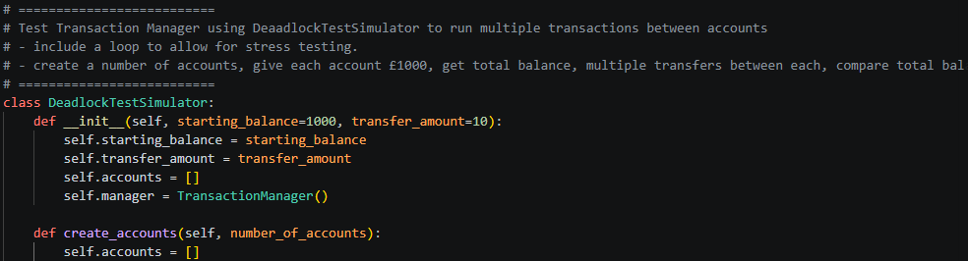
DeadlockTestSimulator was created to validate transfer behaviour between multiple accounts. This separation allowed deadlock prevention to be tested independently of the core functionality.
As new functionality was introduced, existing methods were re-used rather than duplicated. This allowed the TransactionSimulator and TransactionManager classes to utilise the existing deposit, withdraw and get_balance methods.
By separating functionality in this way, when additional features were introduced, there was no requirement to make significant changes to the existing base classes.
This is demonstrated by the introduction of the TransactionManager. Here I was able to
co-ordinate transfers between accounts without modifying the core account functionality. This allowed for a more concise application of the deadlock prevention and overdraft validation logic.

Concurrency and Parallelism
A key objective of the project was to ensure that concurrent transactions would not cause invalid results when adjusting balances. The approach chosen to address this was to introduce threads, each representing a user, and have a TransactionSimulator simulate concurrent activity.
Figure D
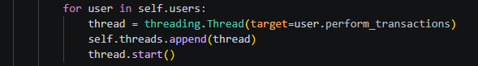

Enabling threads allowed the program to handle concurrency by allowing multiple transactions to be processed at the same time. Without introducing an appropriate mechanism, concurrent transactions could have resulted in a race condition, which would lead to inconsistent results.
To address this, a lock was introduced within the BankAccount class methods. By acquiring the lock before any transaction is processed, only one thread is able to access, and therefore modify, an account’s values at a time. This ensures transactions are processed correctly and the account balance remains consistent.
Figure E
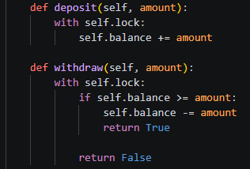

The withdraw method was also extended to include overdraft protection, checking the balance is greater than or equal to the amount, ensuring sufficient funds exist before processing the transaction.

Transfer Management and Deadlock Prevention
Whilst the BankAccount class was sufficient for deposits and withdrawals against a single account, additional functionality was introduced to enable transfers between accounts. To achieve this, a TransactionManager class was added to to coordinate transfers whilst maintaining thread safety.
A potential issue with concurrent transactions between accounts is deadlock, leading to an indefinite wait for resources which are locked by competing threads. To prevent this, locks were acquired in account number order (lowest first) before a transaction was processed.
Figure F
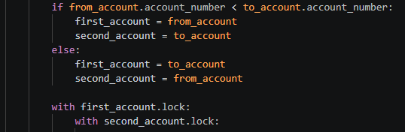
By enforcing this consistent lock order, circular wait conditions could not occur. This ensured transfers were processed safely without causing threads to wait indefinitely.

Testing and Validation
To validate the project, a combination of unit tests and simulation-based tests were developed. The unit tests were used to validate the behaviour of individual classes and methods, whilst the simulators were used to demonstrate the success of the thread safety, deadlock prevention and data integrity mechanisms introduced to support concurrent workloads.

Unit Testing
The first stage of testing validated the behaviour of individual classes and methods. Tests were created to verify account creation, deposits, withdrawals, balance retrieval, overdraft protection, transaction processing, transfer management and deadlock prevention.
Figure G shows the output from the unit tests, showing all tests completed successfully.
Figure G
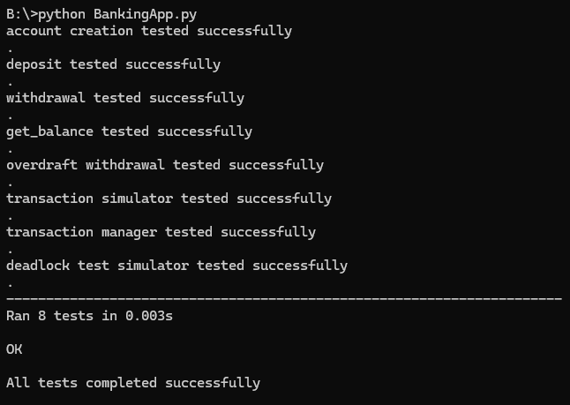
Table 1 summarises the purpose and outcome of each unit test.

Test | Purpose | Result
Account Creation | Validate account initialisation | Pass
Deposit | Validate balance increase | Pass
Withdrawal | Validate balance decrease | Pass
Get Balance | Validate balance retrieval | Pass
Overdraft Withdrawal | Validate insufficient funds handling | Pass
Transaction Simulator | Validate concurrent transaction processing | Pass
Transaction Manager | Validate transfer processing | Pass
Deadlock Test Simulator | Validate deadlock prevention | Pass

TransactionSimulator Testing

Following successful unit testing, the TransactionSimulator was used to validate thread safety under concurrent workloads. Multiple users were simulated using separate threads, each performing deposits and withdrawals against the same BankAccount instance.
Figure H shows the result of a simulation involving 50 users, each performing 100 transactions.

Figure H
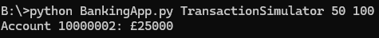

The expected outcome of the test was calculated from the known behaviour of each transaction. Each user deposited £10 and then withdrew £5, resulting in a net increase of £5. Therefore, 50 users completing 100 transactions each would be expected to increase the account balance by £25,000.
The final account balance matched the expected value, demonstrating that concurrent transactions were processed correctly and that the locking mechanism successfully prevented race conditions from occurring.

OverdraftTransferTest Testing

Whilst the TransactionSimulator validated concurrent access to a single account, the OverdraftTransferTest was used to validate concurrent transfers between multiple accounts. This test was designed to demonstrate the effectiveness of the deadlock prevention and overdraft protection mechanisms introduced during development.
Figure I shows the output from a test involving seven accounts, each with a starting balance of £100 and a transfer amount of £50.
Figure I
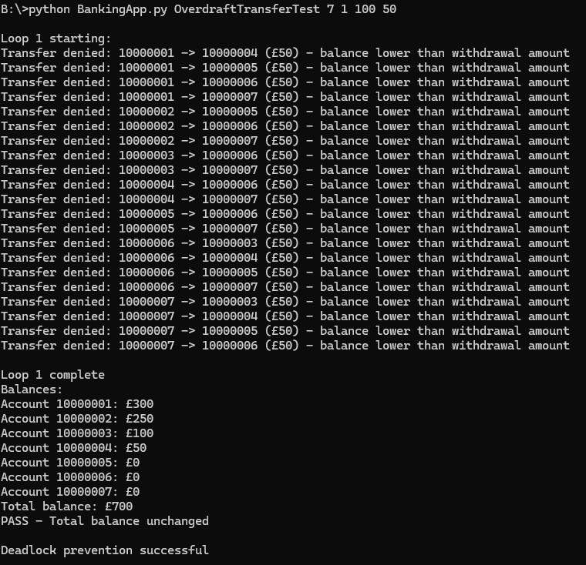
Figure I demonstrates that transfers were correctly denied when an account contained insufficient funds. As the accounts attempted to complete the steps, the reduced balances resulted in failed transactions.
Despite these failed transactions, the total balance across all accounts did not change, demonstrating the ability of the system to maintain data integrity during concurrent processing.
This test also successfully demonstrated that the lock ordering strategy implemented within the TransactionManager prevented deadlock, allowing all threads to complete without encountering an indefinite wait state.

Conclusion
The project successfully delivered a thread-safe banking system capable of supporting concurrent transactions whilst maintaining data integrity. Object-orientated programming principles were demonstrated through the application of abstraction and encapsulation, whilst also applying design principles such as the Single Responsibility Principle to improve maintainability.
Additional functionality was implemented through the TransactionManager, which enabled safe account transfers and prevented deadlock through a consistent lock ordering strategy. Overdraft protection was also introduced to prevent invalid transactions from being processed.
Finally, testing was used to demonstrate the system continued to behave as intended for both normal and concurrent transactions, validating the thread safety and deadlock prevention mechanisms introduced during development.

Appendix A

Reproducing Test Results
The application was parameterised to allow the testing scenarios to be reproduced with different values. The following commands were used during the testing referenced in this report:
Run unit tests:
python BankingApp.py
Run TransactionSimulator with 50 users performing 100 transactions each:
python BankingApp.py TransactionSimulator 50 100
Run DeadlockTestSimulator with 10 accounts and 3 test loops:
python BankingApp.py DeadlockTestSimulator 10 3
Run OverdraftTransferTest with 7 accounts, 1 loop, a starting balance of £100 and a transfer amount of £50:
python BankingApp.py OverdraftTransferTest 7 1 100 50
The parameters can be modified to vary the number of accounts, loops, transactions or transfer amounts in order to perform additional validation and stress testing.

